SEC Form 4
FORM 4 |  | UNITED STATES SECURITIES AND EXCHANGE COMMISSION  Washington, D.C. 20549  STATEMENT OF CHANGES IN BENEFICIAL OWNERSHIP  Filed pursuant to Section 16(a) of the Securities Exchange Act of 1934  or Section 30(h) of the Investment Company Act of 1940
  OMB APPROVAL
  OMB Number: | 3235-0287
  Estimated average burden
  hours per response: | 0.5
 | Check this box if no longer subject to Section 16. Form 4 or Form 5 obligations may continue. See Instruction 1(b).
 | Check this box to indicate that a transaction was made pursuant to a contract, instruction or written plan for the purchase or sale of equity securities of the issuer that is intended to satisfy the affirmative defense conditions of Rule 10b5-1(c). See Instruction 10.
1. Name and Address of Reporting Person*  (Street) | 2. Issuer Name and Ticker or Trading Symbol  James River Group Holdings, Inc. [ JRVR ] | 5. Relationship of Reporting Person(s) to Issuer  (Check all applicable)
  Sutherland Todd Randell
  (Last) | (First) | (Middle)
  C/O JAMES RIVER GROUP HOLDINGS, INC.
  1414 RALEIGH ROAD, SUITE 405
  CHAPEL HILL | NC | 27517
  (City) | (State) | (Zip)
   | Director |  | 10% Owner
   | Officer (give title below) |  | Other (specify below)
  President, E&S Lines Segment
3. Date of Earliest Transaction (Month/Day/Year)
05/04/2026
 | 4. If Amendment, Date of Original Filed (Month/Day/Year) | 6. Individual or Joint/Group Filing (Check Applicable Line)
  Form filed by One Reporting Person
  Form filed by More than One Reporting Person
Table I - Non-Derivative Securities Acquired, Disposed of, or Beneficially Owned
1. Title of Security (Instr. 3) | 2. Transaction Date (Month/Day/Year) | 2A. Deemed Execution Date, if any (Month/Day/Year) | 3. Transaction Code (Instr. 8) |  | 4. Securities Acquired (A) or Disposed Of (D) (Instr. 3, 4 and 5) |  |  | 5. Amount of Securities Beneficially Owned Following Reported Transaction(s) (Instr. 3 and 4) | 6. Ownership Form: Direct (D) or Indirect (I) (Instr. 4) | 7. Nature of Indirect Beneficial Ownership (Instr. 4)
1. Title of Security (Instr. 3) | 2. Transaction Date (Month/Day/Year) | 2A. Deemed Execution Date, if any (Month/Day/Year) | Code | V | Amount | (A) or (D) | Price |  | 6. Ownership Form: Direct (D) or Indirect (I) (Instr. 4) | 7. Nature of Indirect Beneficial Ownership (Instr. 4)
Common Stock | 05/04/2026 |  | F |  | 937(1) | D | $6.13 | 95,293 | D
Table II - Derivative Securities Acquired, Disposed of, or Beneficially Owned
(e.g., puts, calls, warrants, options, convertible securities)
1. Title of Derivative Security (Instr. 3) | 2. Conversion or Exercise Price of Derivative Security | 3. Transaction Date (Month/Day/Year) | 3A. Deemed Execution Date, if any (Month/Day/Year) | 4. Transaction Code (Instr. 8) |  | 5. Number of Derivative Securities Acquired (A) or Disposed of (D) (Instr. 3, 4 and 5) |  | 6. Date Exercisable and Expiration Date (Month/Day/Year) |  | 7. Title and Amount of Securities Underlying Derivative Security (Instr. 3 and 4) |  | 8. Price of Derivative Security (Instr. 5) | 9. Number of derivative Securities Beneficially Owned Following Reported Transaction(s) (Instr. 4) | 10. Ownership Form: Direct (D) or Indirect (I) (Instr. 4) | 11. Nature of Indirect Beneficial Ownership (Instr. 4)
 |  |  |  | Code | V | (A) | (D) | Date Exercisable | Expiration Date | Title | Amount or Number of Shares
Explanation of Responses:
1. The shares disposed of were withheld by James River Group Holdings, Inc. for payment of the tax liability incident to the vesting of 3,111 restricted share units on May 4, 2026.
Remarks:
 | /s/ Jeanette L. Miller, Attorney-in-fact for Todd R. Sutherland | 05/05/2026
 | ** Signature of Reporting Person | Date
Reminder: Report on a separate line for each class of securities beneficially owned directly or indirectly.
* If the form is filed by more than one reporting person, see Instruction 4 (b)(v).
** Intentional misstatements or omissions of facts constitute Federal Criminal Violations See 18 U.S.C. 1001 and 15 U.S.C. 78ff(a).
Note: File three copies of this Form, one of which must be manually signed. If space is insufficient, see Instruction 6 for procedure.
Persons who respond to the collection of information contained in this form are not required to respond unless the form displays a currently valid OMB Number.
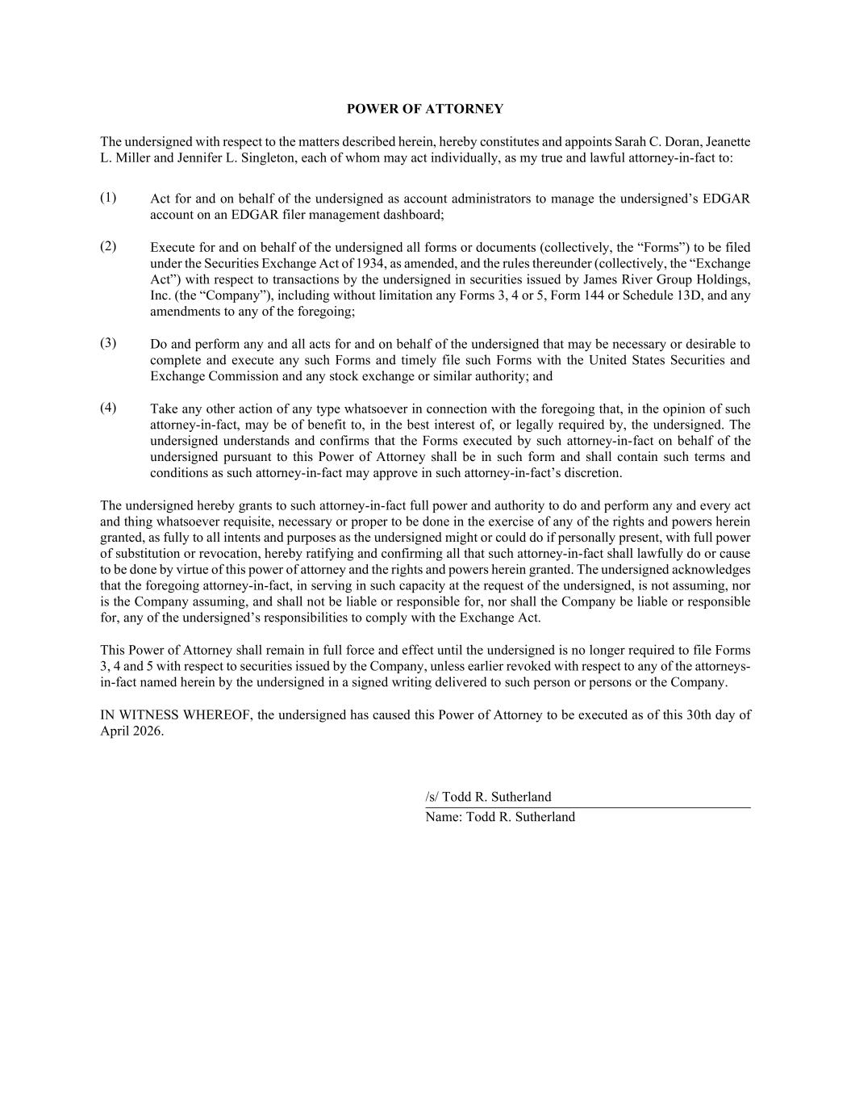
POWER OF ATTORNEY The undersigned with respect to the matters described herein, hereby constitutes and appoints Sarah C. Doran, Jeanette L. Miller and Jennifer L. Singleton, each of whom may act individually, as my true and lawful attorney-in-fact to: (1) Act for and on behalf of the undersigned as account administrators to manage the undersigned’s EDGAR account on an EDGAR filer management dashboard; (2) Execute for and on behalf of the undersigned all forms or documents (collectively, the “Forms”) to be filed under the Securities Exchange Act of 1934, as amended, and the rules thereunder (collectively, the “Exchange Act”) with respect to transactions by the undersigned in securities issued by James River Group Holdings, Inc. (the “Company”), including without limitation any Forms 3, 4 or 5, Form 144 or Schedule 13D, and any amendments to any of the foregoing; (3) Do and perform any and all acts for and on behalf of the undersigned that may be necessary or desirable to complete and execute any such Forms and timely file such Forms with the United States Securities and Exchange Commission and any stock exchange or similar authority; and (4) Take any other action of any type whatsoever in connection with the foregoing that, in the opinion of such attorney-in-fact, may be of benefit to, in the best interest of, or legally required by, the undersigned. The undersigned understands and confirms that the Forms executed by such attorney-in-fact on behalf of the undersigned pursuant to this Power of Attorney shall be in such form and shall contain such terms and conditions as such attorney-in-fact may approve in such attorney-in-fact’s discretion. The undersigned hereby grants to such attorney-in-fact full power and authority to do and perform any and every act and thing whatsoever requisite, necessary or proper to be done in the exercise of any of the rights and powers herein granted, as fully to all intents and purposes as the undersigned might or could do if personally present, with full power of substitution or revocation, hereby ratifying and confirming all that such attorney-in-fact shall lawfully do or cause to be done by virtue of this power of attorney and the rights and powers herein granted. The undersigned acknowledges that the foregoing attorney-in-fact, in serving in such capacity at the request of the undersigned, is not assuming, nor is the Company assuming, and shall not be liable or responsible for, nor shall the Company be liable or responsible for, any of the undersigned’s responsibilities to comply with the Exchange Act. This Power of Attorney shall remain in full force and effect until the undersigned is no longer required to file Forms 3, 4 and 5 with respect to securities issued by the Company, unless earlier revoked with respect to any of the attorneys- in-fact named herein by the undersigned in a signed writing delivered to such person or persons or the Company. IN WITNESS WHEREOF, the undersigned has caused this Power of Attorney to be executed as of this 30th day of April 2026. /s/ Todd R. Sutherland Name: Todd R. Sutherland

